**SmartIntern Long Term Virtual Internship**

An Internship Report submitted in partial fulfillment of the requirements for the award of degree of

**BACHELOR OF TECHNOLOGY**

## In

**MECH – MECHANICAL ENGINEERING**

**Submitted by:**

**CHEEPURU SAI PRASAD 21W65A0304**

**GOLLAPALI BHARAT KUMAR 21W65A0208**

**PANGA JAGADEESH 21W65A0222**

**CHINNALA AMARNATH 20W61A0305**

**ARDAPAKULA BHASKAR 21W65A0202**



**Department Of Mechanical Engineering**

**SRI SIVANI COLLEGE OF ENGINEERING**

**Approved By AICTE & Affiliated to JNTUGV**

**Chilakapalem Jn., Srikakulam 532402**

### *Wanderlust: A Personalized Travel Planning And Tracking App*

**Project Description:**

**A project built using the Android Compose UI toolkit. It demonstrates how to create a simple travel app using the Compose libraries. It also features a personalized feed of recommended accommodations based on the locations.**

**Architecture:**

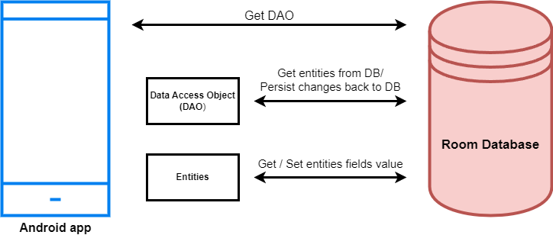

**Learning Outcomes :**

**By end of this project:**

* **You’ll be able to work on Android studio and build an app.**
* **You’ll be able to integrate the database accordingly.**

**Project Workflow:**

* **Users register into the application.**
* **After registration , user logins into the application.**
* **User enters into the main page**

**Note:**

**To complete the project you need to finish up the tasks listed below:**

**Tasks:**

**1.Required initial steps**

**2.Creating a new project.**

**3.Adding required dependencies.**

**4.Creating the database classes.**

**5.Building application UI and connecting to database.**

**6.Using AndroidManifest.xml**

**7.Running the application.**

### Required Initial Steps

**This milestone explains about required initial steps.**

<https://developer.android.com/studio/install>

### Creating A New Project

**Creating a new project.**

**Step 1 : Android studio > File > New > New Project > Empty Compose Activity**

**Step 2 : Click on Next button.**

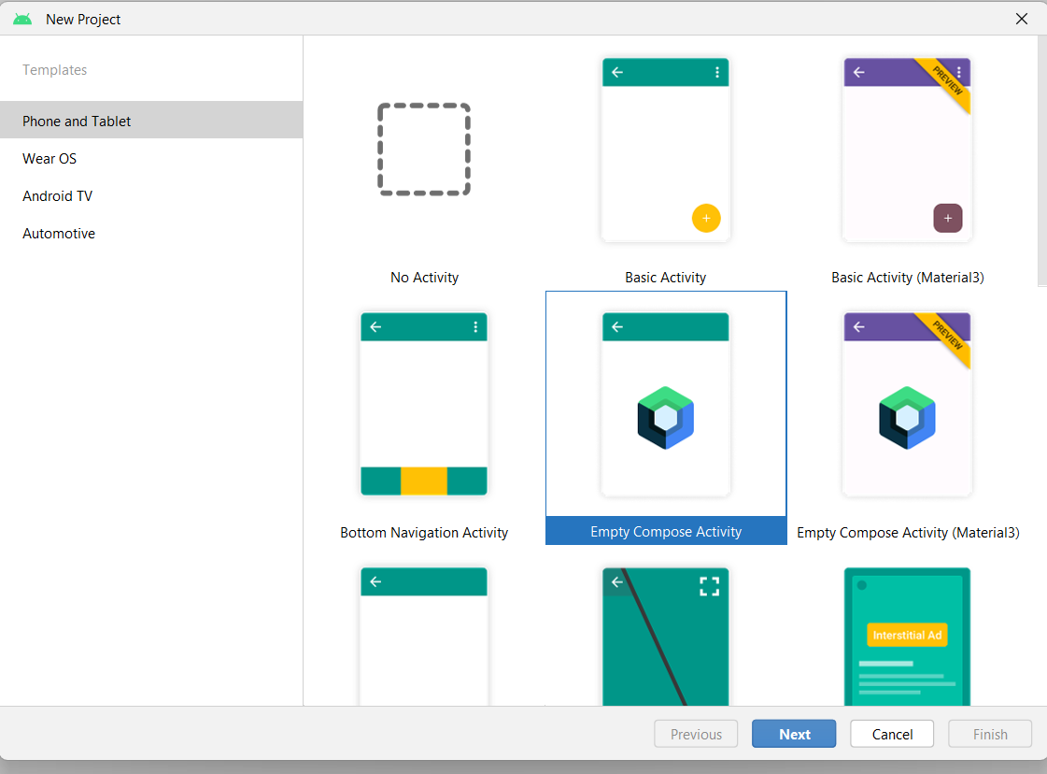

**Step 3 : Give name to the new project.**

**Step 4 : Give the Minimum SDK value**

**Step 5 : Click Finish**

**Main activity file**

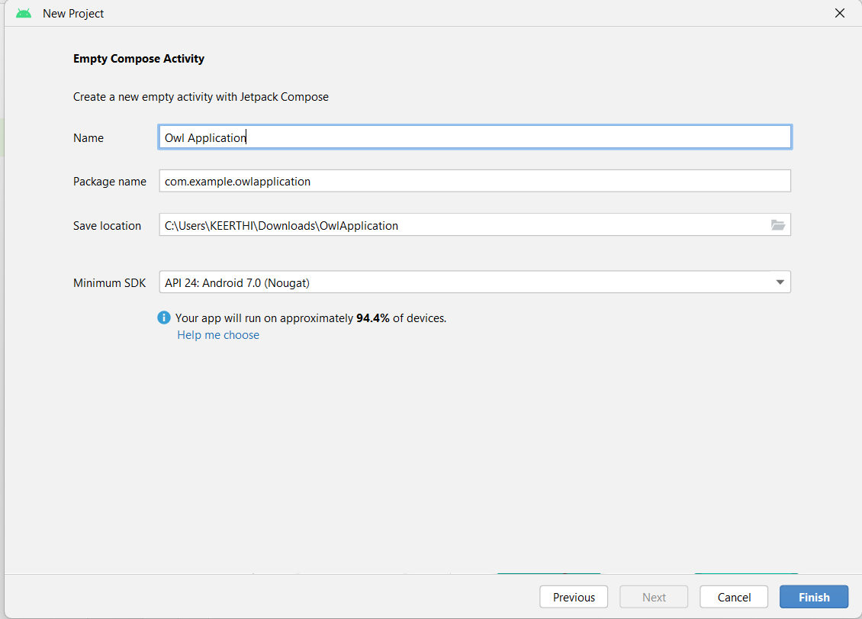

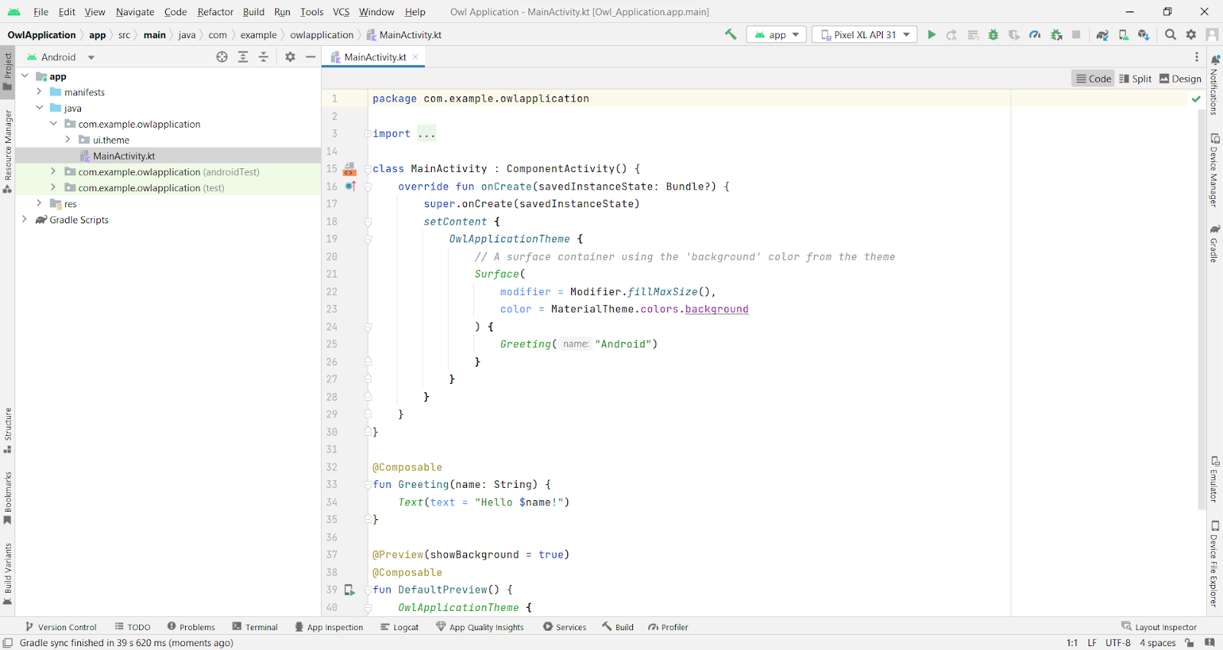

### Adding Required Dependencies

**This milestone explains about adding Required dependencies.**

### Gradle Scripts > Build.Gradle(Module :App)

**Gradle scripts > build.gradle(Module :app)**

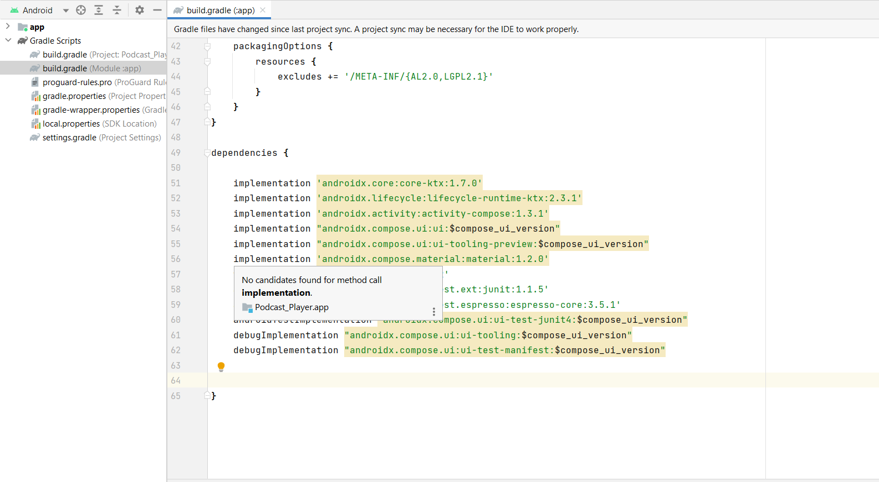

**Add the below code in dependencies**

*// Adding Room dependencies*

implementation 'androidx.room:room-common:2.5.0'

implementation 'androidx.room:room-ktx:2.5.0'

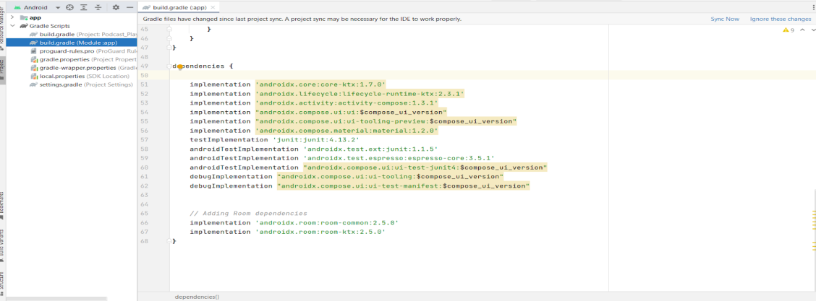

**Step 3 : Click on Sync now**

### Creating The Database Classes

**This milestone explains about Creating the database classes.**

**Create User data class**

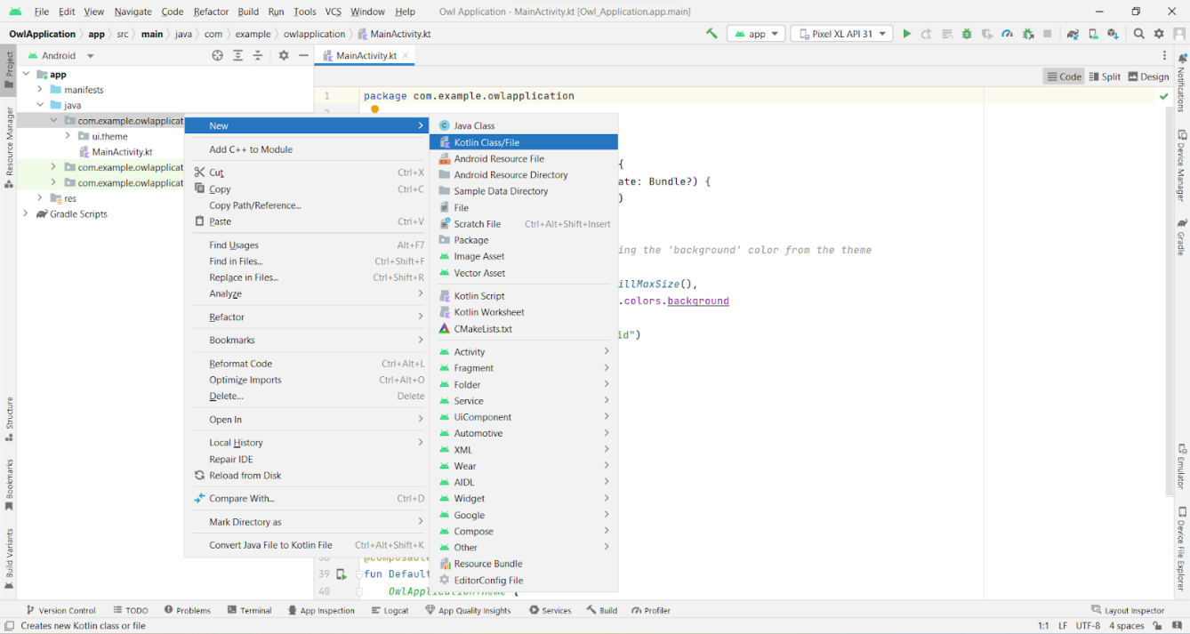

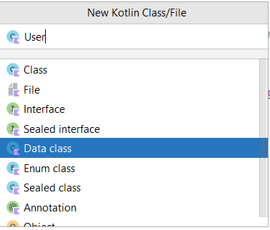

**Create an UserDao interface**

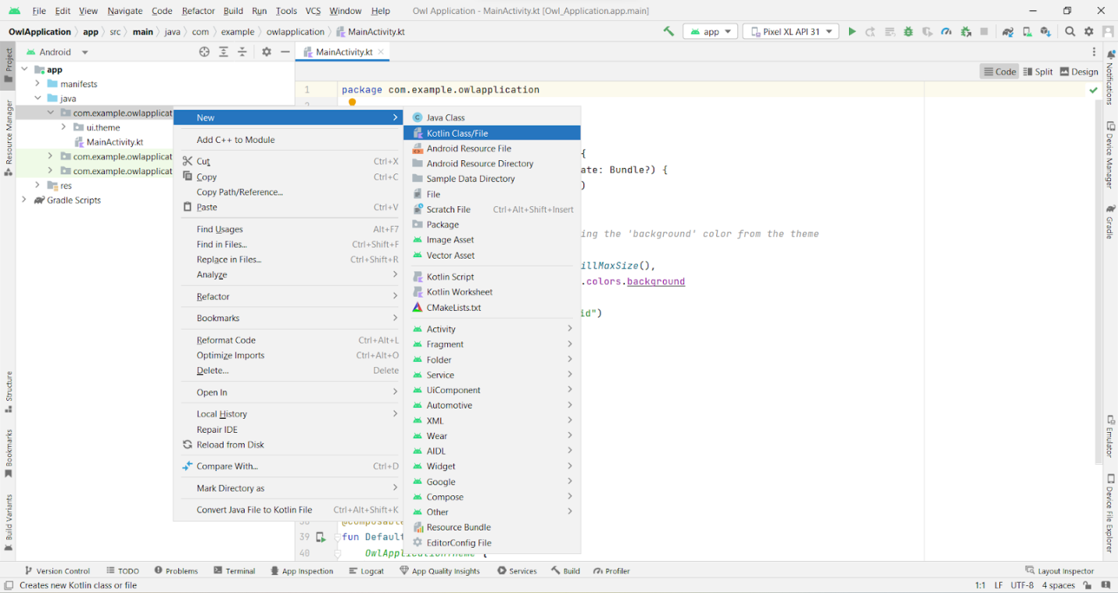

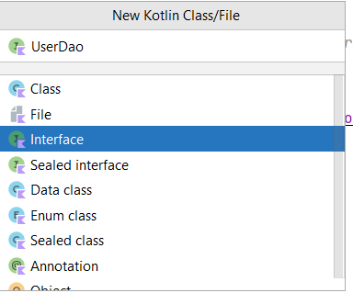

**Create an UserDatabase class**

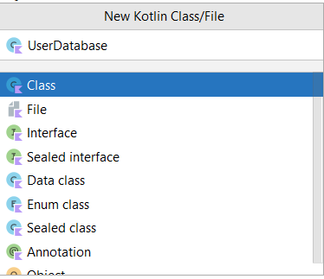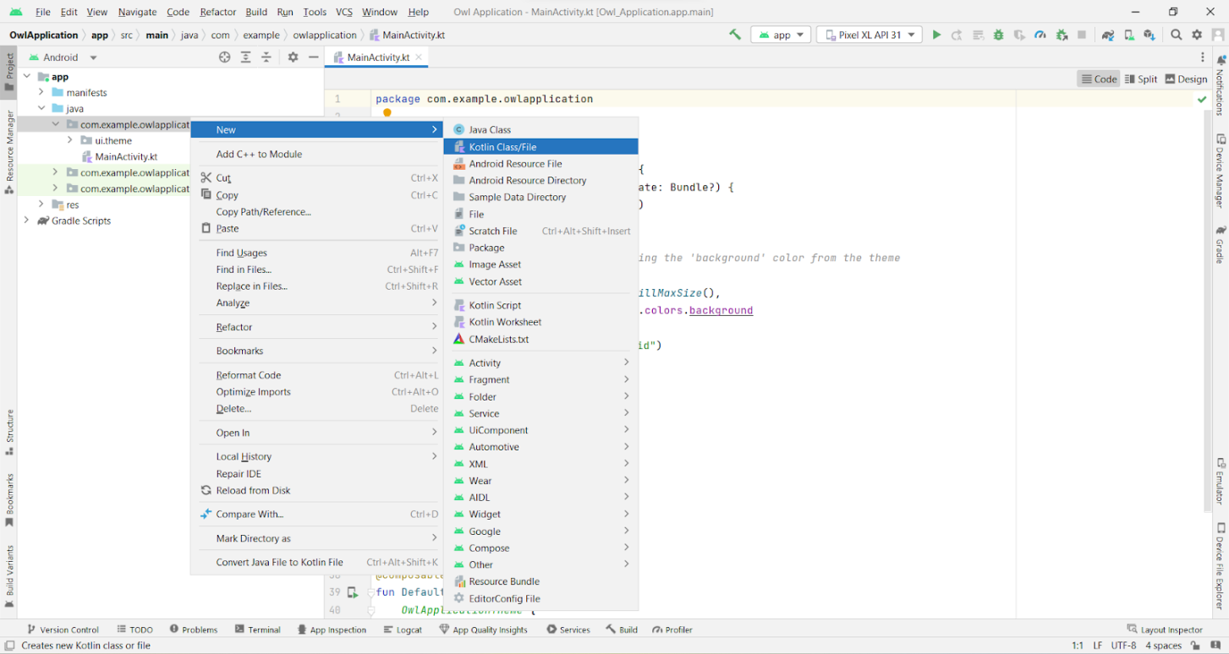

**Create an UserDatabaseHelper class**



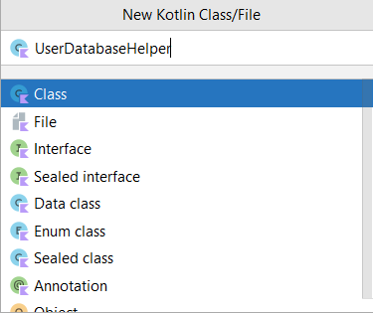

### Building Application UI And Connecting To Database

**This milestone explains about building application UI and connecting to database**

**Creating LoginActivity.kt with database**

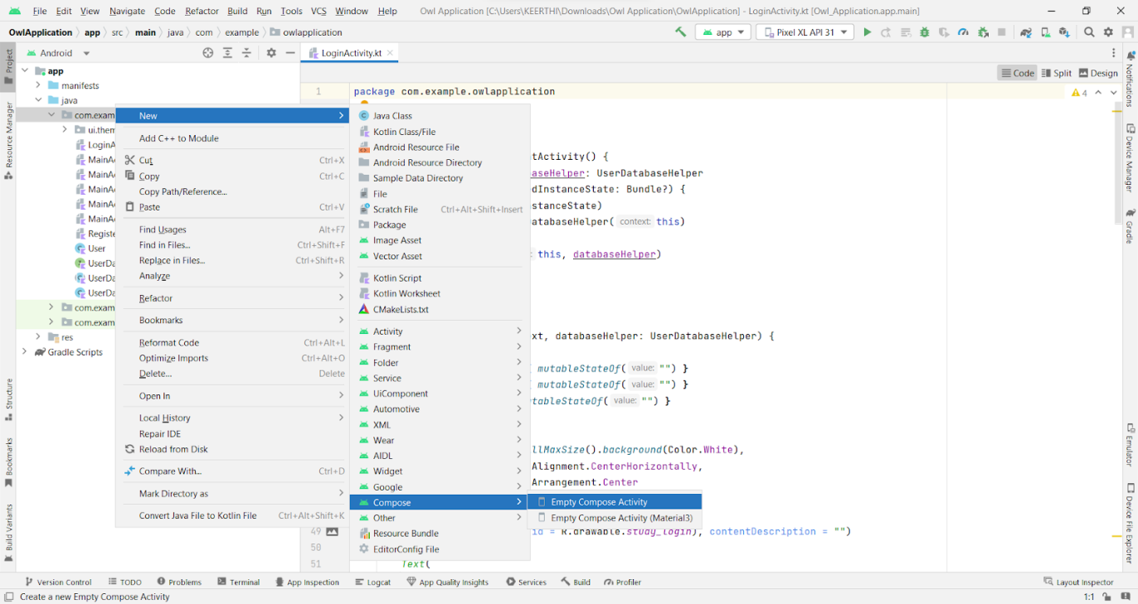

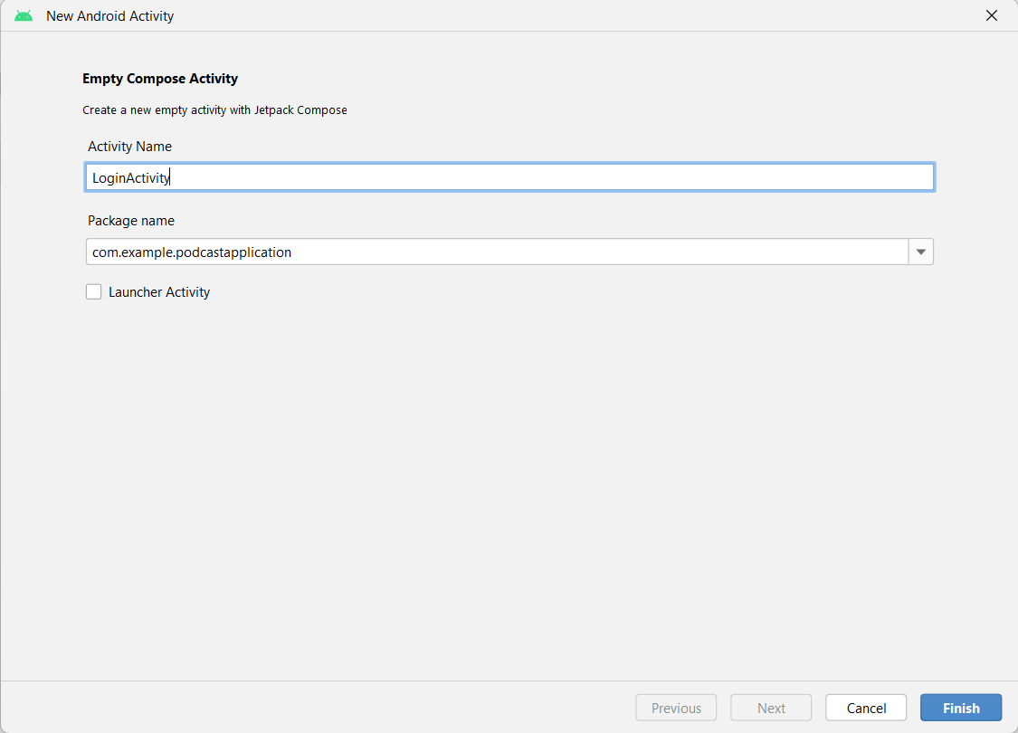

**Database connection in LoginActivity.kt**

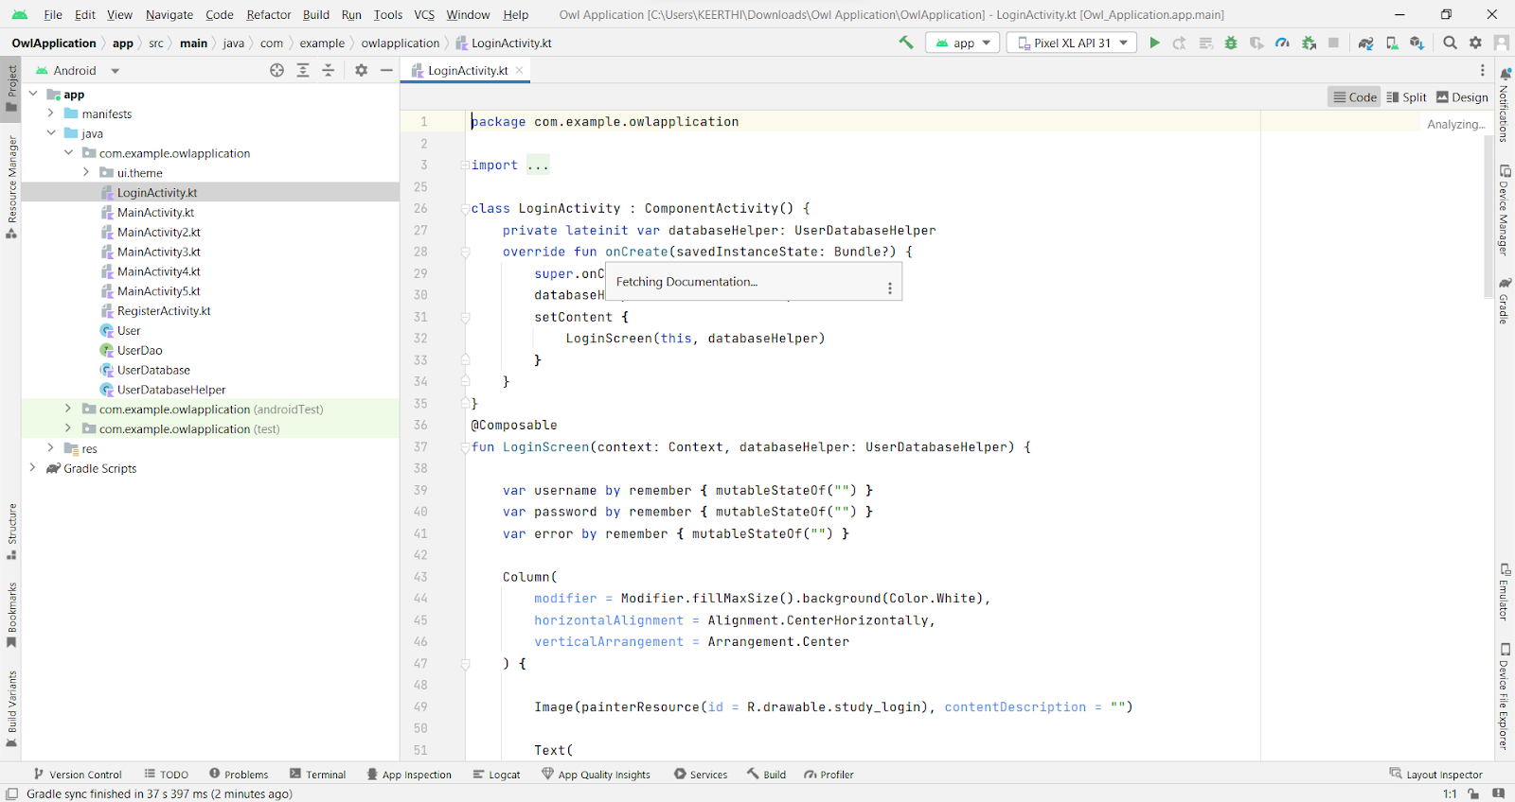

**Creating RegisterActivity.kt with database**

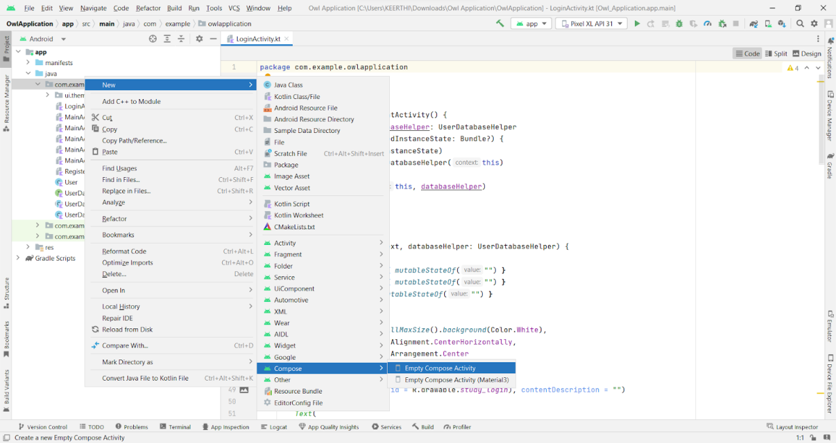

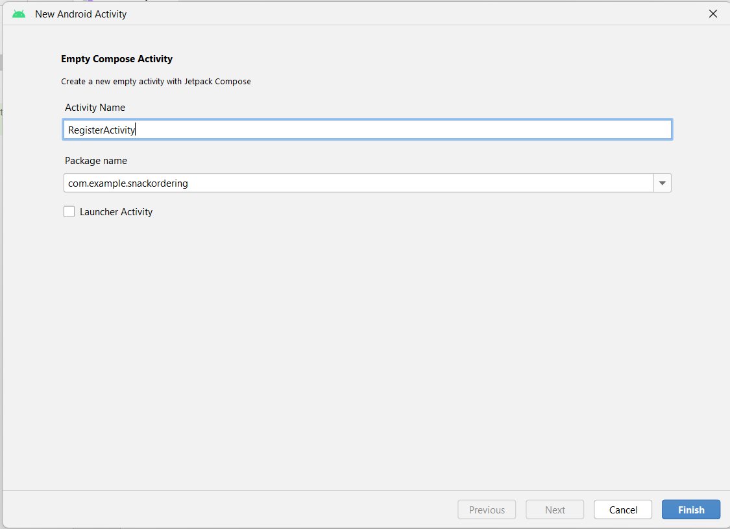

**Database connection in RegisterActivity.kt**

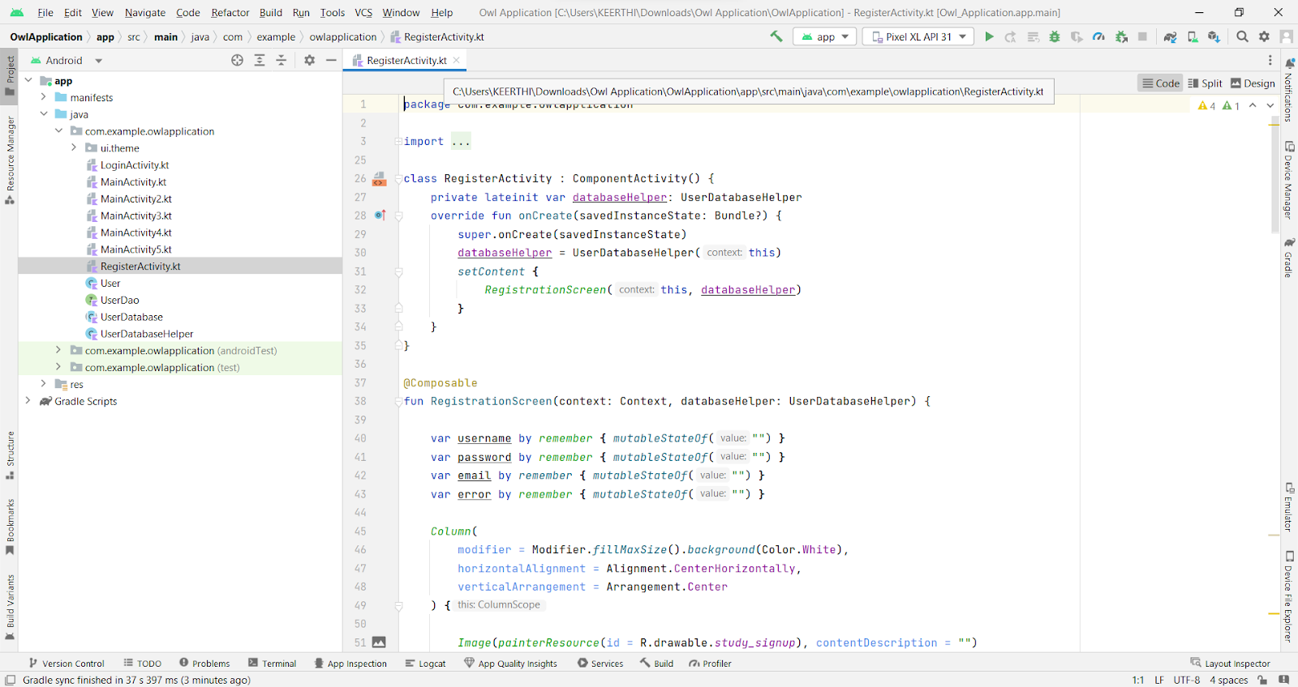

### Creating MainActivity.Kt File

**In MainActivity.kt file the main application is developed**

* 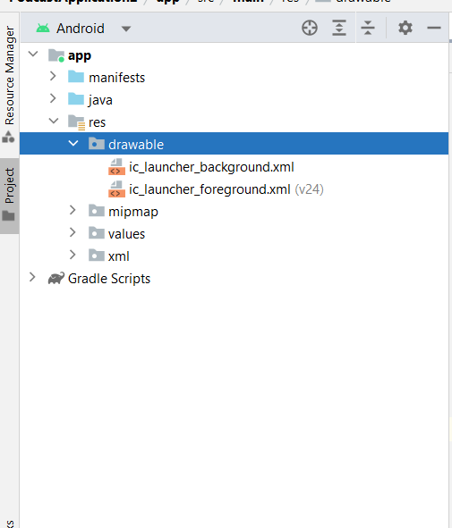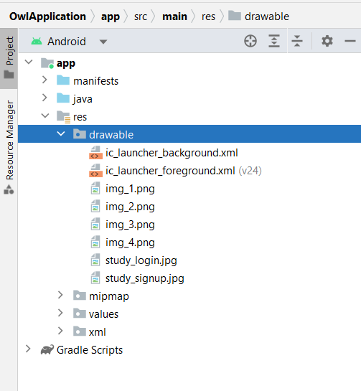**Before creating UI we need to add some images in drawables which are in res**

**MainActivity.kt**

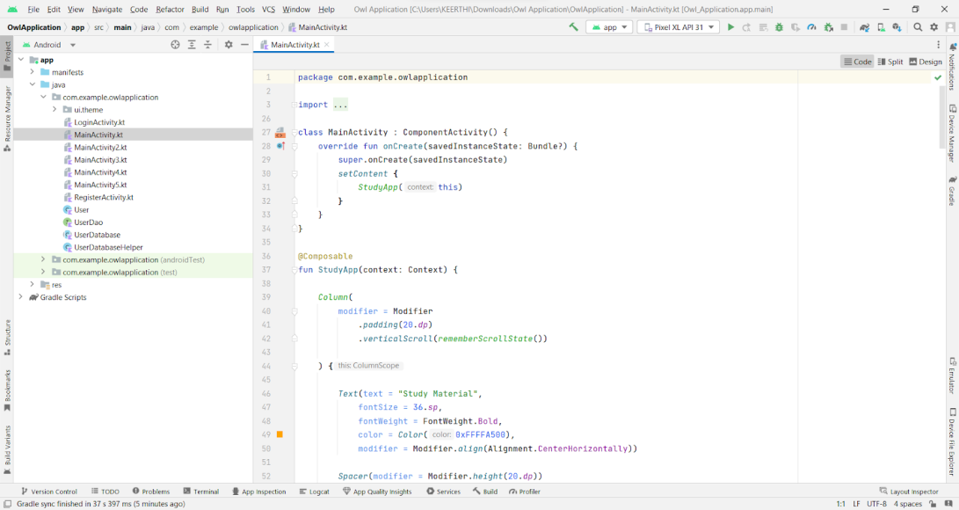

**Creating BaliActivity.kt file**

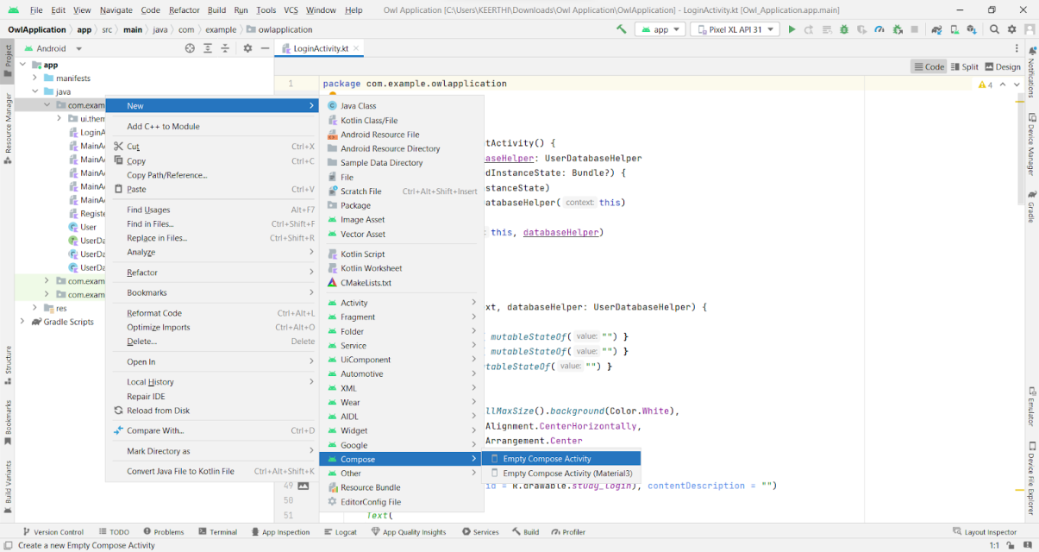

**BaliActivity.kt**

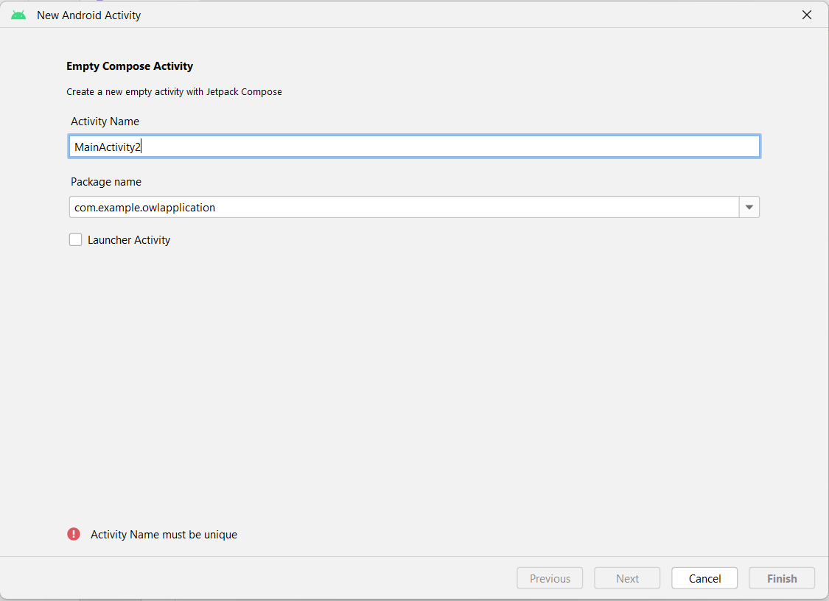

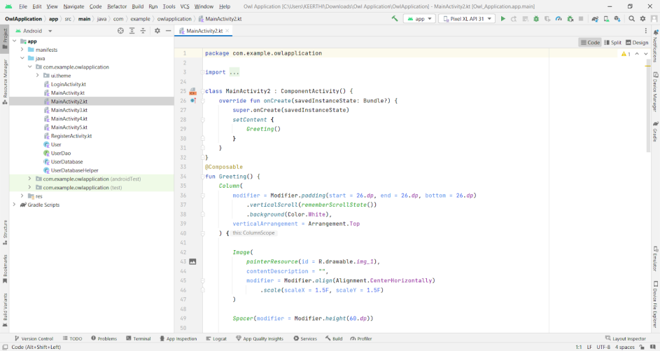

**Creating ParisActivity.kt file**

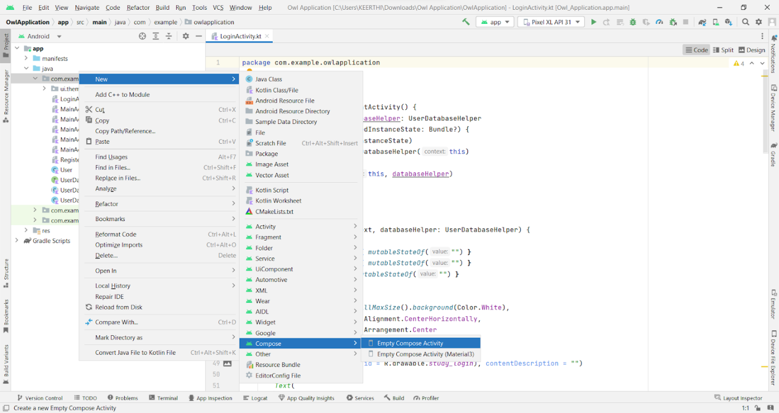

**ParisActivity.kt file**

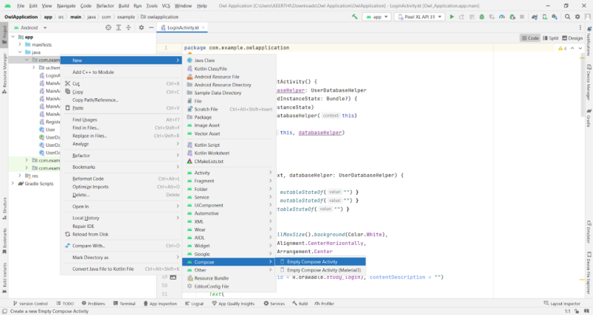

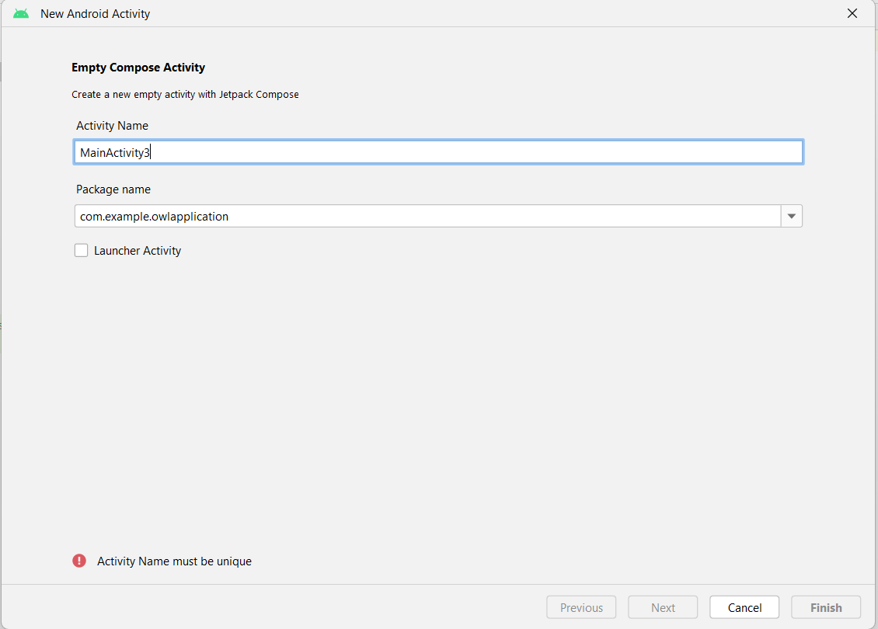

**Creating SingaporeActivity.kt file**

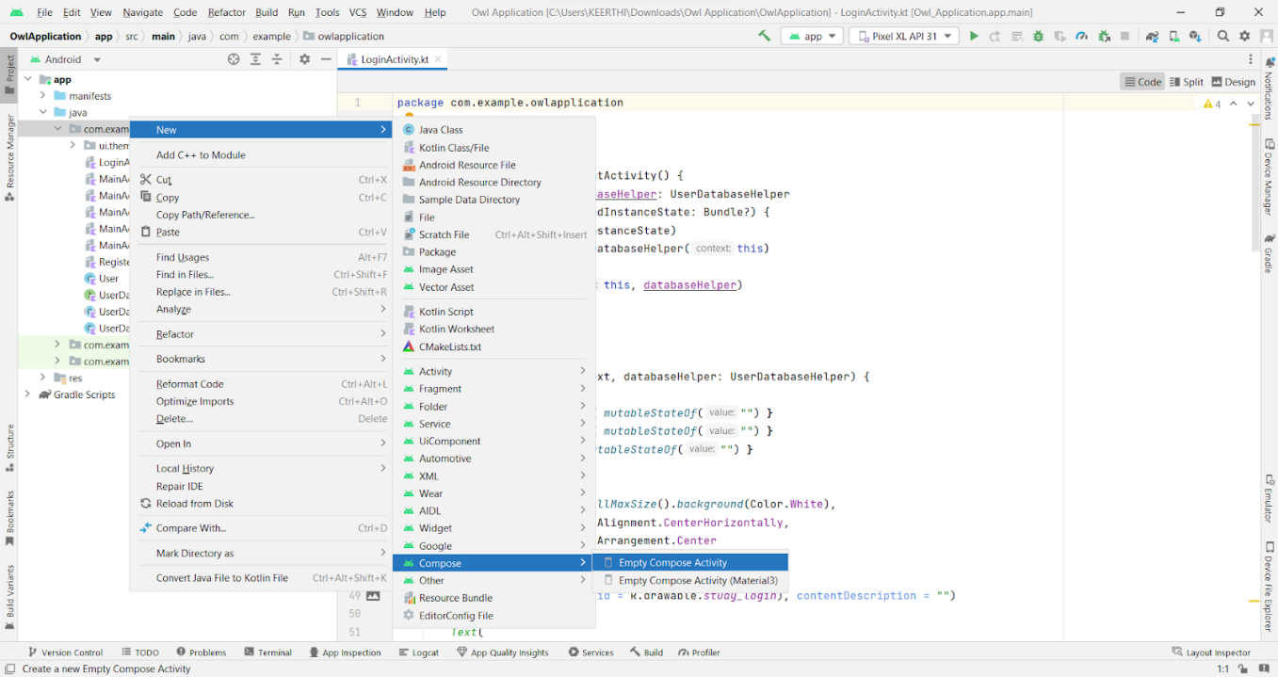

**SingaporeActivity.kt file**

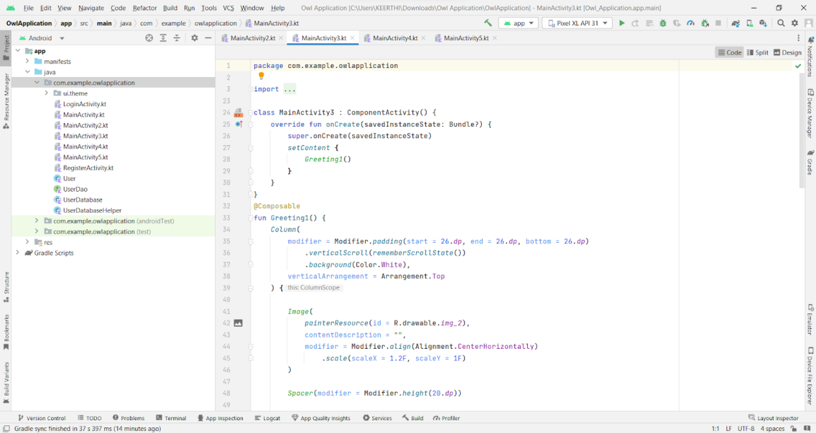

### Modifying AndroidManifest.Xml

**Modifying AndroidManifest.xml**

**When we run the app we will get the MainActivity.kt file as our first screen , but we want LoginActivity.kt , So we need to change in AndroidManifest.xml.**

**Changed AndroidManifest.xml**

### Running The Application

**This milestone explains about running the application.**

**RUN IN A DEVICE**

**Run apps on a hardware device**

<https://developer.android.com/studio/run/device>

### Run The Application In Mobile

**HOME PAGE**

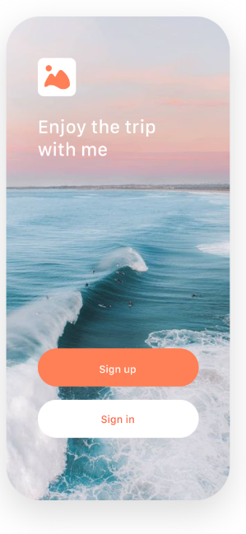

**CREATING A NEW ACCOUNT**

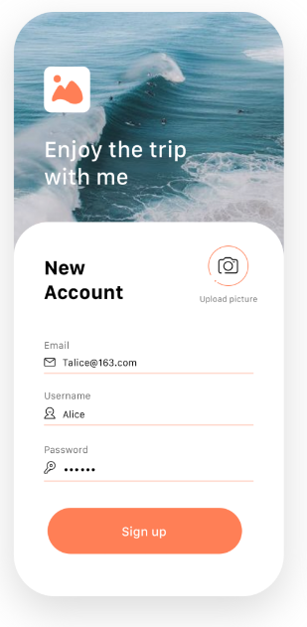

**LOG IN**

